Experiment 4: Create a Scrum Project in Jira
AIM
To create a Scrum project in Jira, add and prioritize at least five backlog items, create a one-week sprint, and track task progress using the sprint board.
PROCEDURE
- Open Jira and log in to your account.
- Create a Scrum project named Online Shopping System.
- Open the Backlog section and add the following five items:
  - Create User Registration Page
  - Develop Login API
  - Create Product Search
  - Develop Shopping Cart
  - Implement Payment Page
- Prioritize the backlog items according to their importance.
- Click Create Sprint and move all five backlog items into the sprint.
- Name the sprint Sprint 1 – Shopping System.
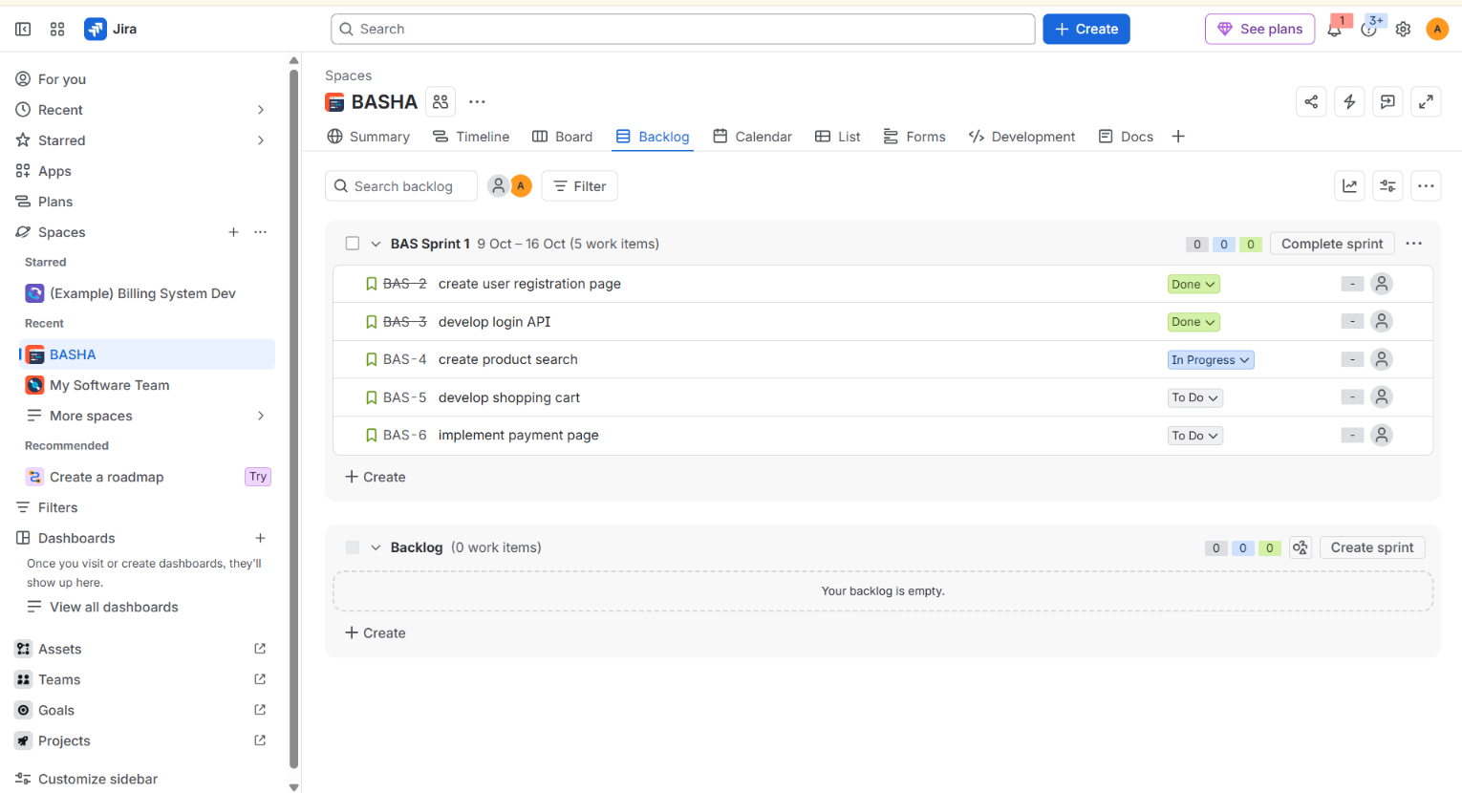
- Click Start Sprint and set the sprint duration to one week.
- Open the sprint board and take a screenshot showing the initial task statuses.
- Move tasks between the To Do, In Progress, and Done columns to demonstrate workflow progress.
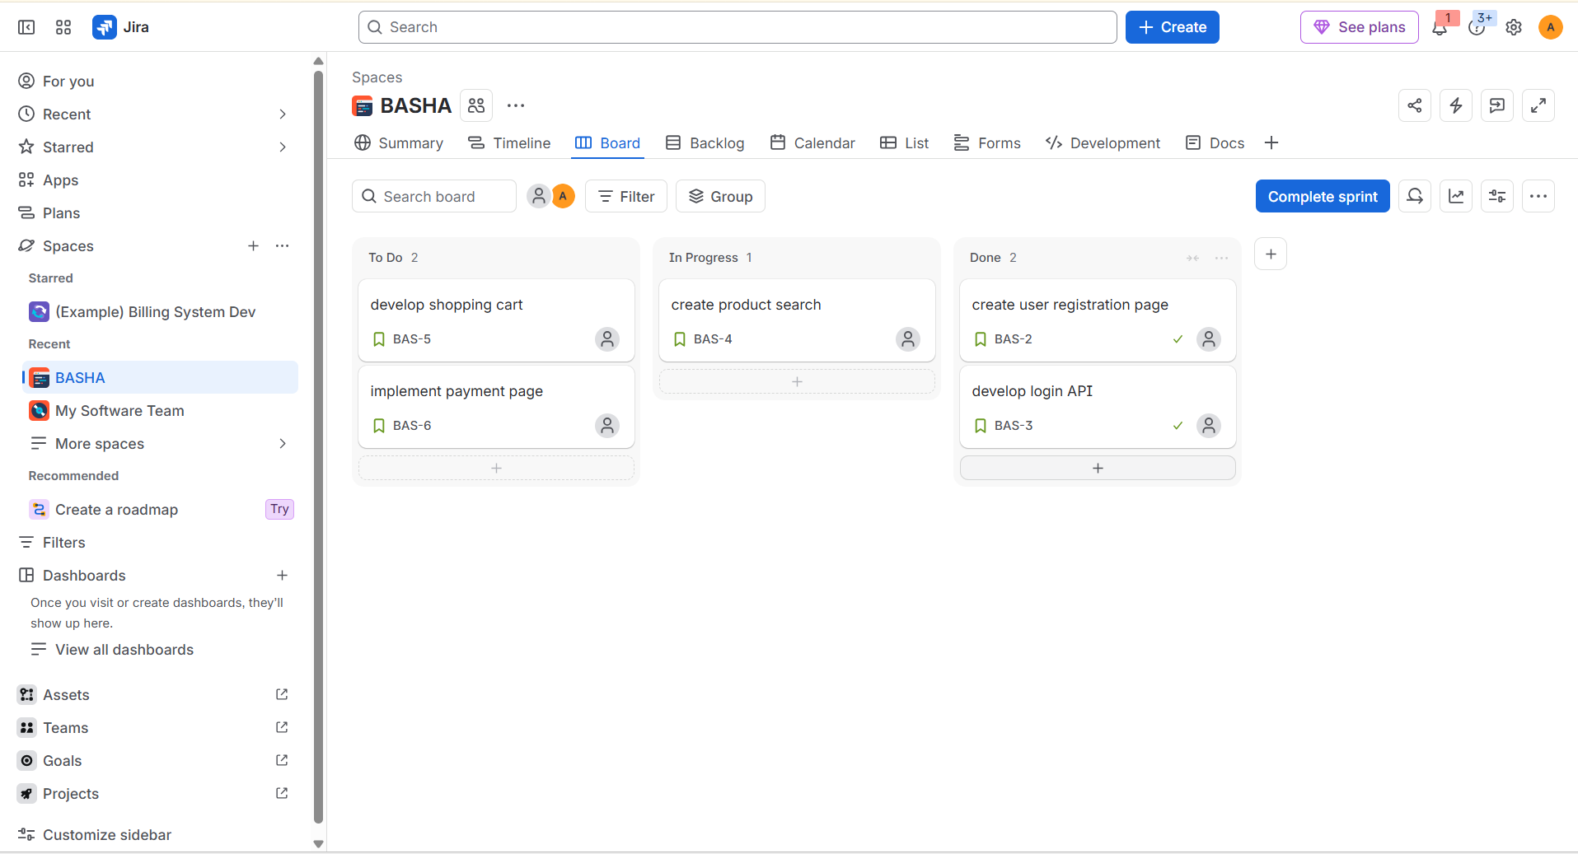
- Take another screenshot showing the updated sprint board for submission.

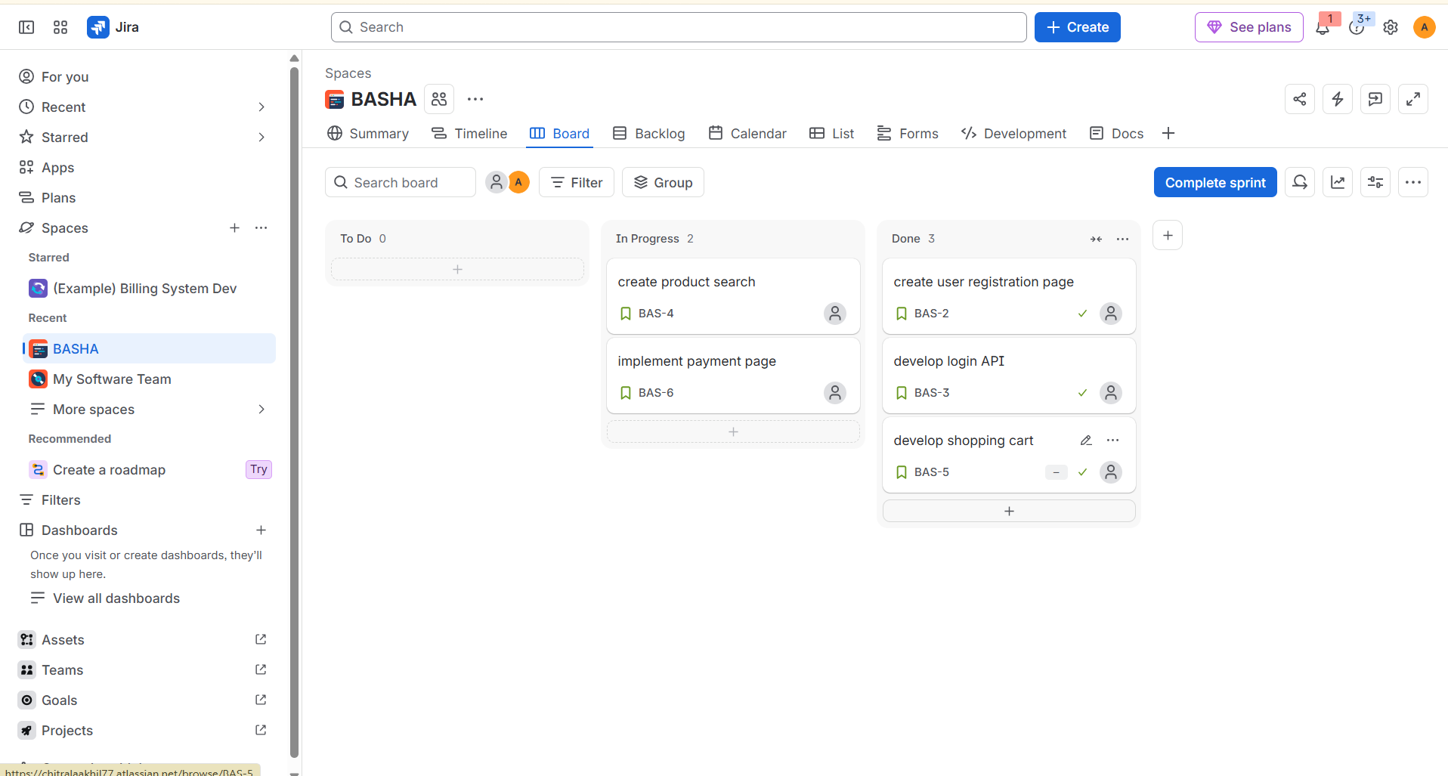
RESULT
A Scrum project was successfully created in Jira with five prioritized backlog items. A one-week sprint was created and started, and the sprint board was used to demonstrate task progress. Screenshots of the sprint board at the start and after the progress demonstration were captured for submission.

